**4 Competences:**Assignments and criteria are used as a tool to professionally approach problem solving. But you’re also in the process of building your ***own personal competence profile.*** If you graduate in the ‘Digitale transormatieopleiding’, you even get a personalized diploma.To get a grip on how you’re developing as an IT professional, self-selected competences are used to measure this. These indicators have to be attached to your portfolio (just like the criteria) where they will be graded. In this way every assignment helps to build your personal profile.

**What’s in it for me:**This type of education gives you the possibility to create your own curriculum. So, you can develop yourself into any ICT person you like to be, all within your own chosen domain. Because we work with real life challenges, the combination of competences is always meaningful. If you attach these in a consistent manner, you can keep a detailed track of your progress and the forming of your profile.

In Canvas there is even tooling which shows this. (The performance dashboard, called Epsylon, see picture.).

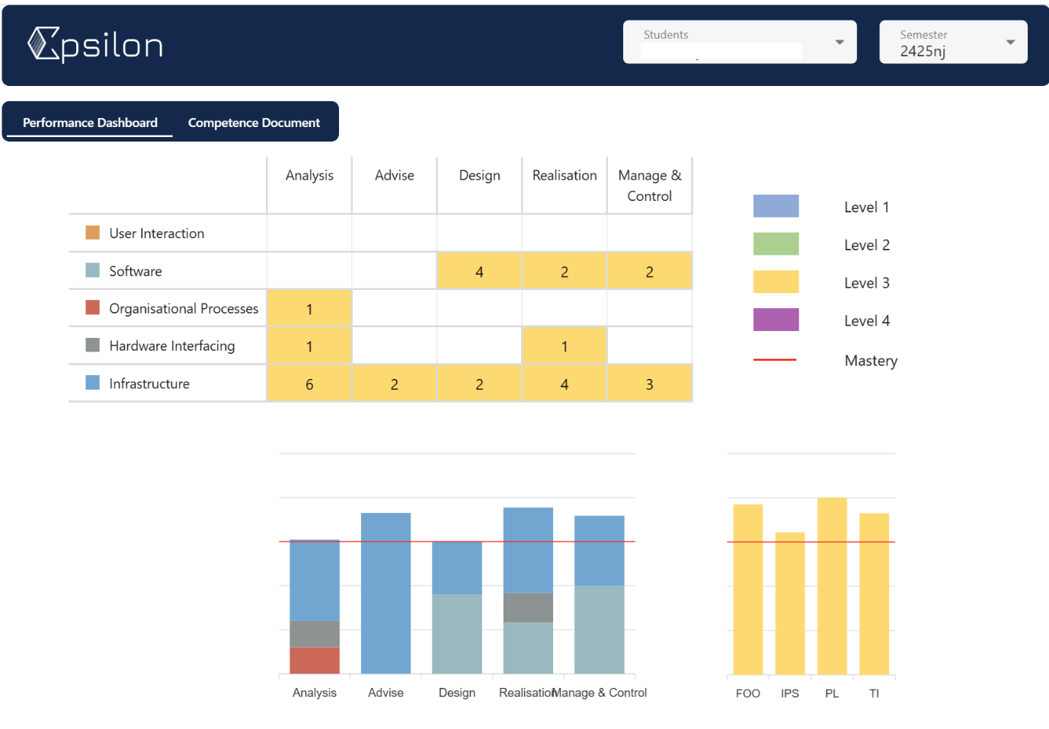

**3.1 the competence framework:** The set of competences that is used is the result from a collaboration with a large number of companies and different institutes. Each semester focusses on at least three aspects: Professional Development Competences, IT competences, and at least one set of competences from another domain. This competence framework describes the field of IT in a multitude of possible combinations of other non-IT disciplines.

**3.2 working with the framework:**Attaching competences to your portfolio can be a daunting task if you do it wrong. So beforehand some tips:

***TIP: Don’t reverse engineer it. Pick the competences at the right moment and it will work for you.***

***TIP: Don’t start directly with adding competences. Make sure to have the assignment and the criteria.  Then start working on picking the right competences. When you have grip on the assignment or do the last turn in, you know what it is about. Add the competences at that moment to your porfolio.***

To make sure a quick recap:

* + - **The matrix**: The framework is created around Competences that basically describe a development lifecycle. And if you look at it, a cyclic returning set of actions can be seen. *Analyze, Desig, Realise, Manage & Control.*These can be seen in the top row

All these competences can be shown in what we call layers or ‘drawers’. Each drawer represents a certain domain. IT is the base of each semester, but always together with one other domain. The compences for each domain are to be found in the layers (or drawers) of the competence model.

Splitting it like this means that you can work on your competences in a choice of layers. This will color your personal profile in that it can be any combination of layers, paired with IT.

* + **The levels: By adding levels this model adds the possibility to grow in certain areas. The framework know’s 4 different levels which describe an increasing complexity. This turns the matrix into a cube.  The meaning of the levels can be translated into the phases of our curriculum. Phase 1 is first year level, phase 2 is corephase (until the internship), phase 3 is graduation level and phase 4 is the master program.**

**For example:** If you’re a software student at Fontys ICT, after your first year all your software skills are on level 1. Say you’re in the second year and work on a challenge that will add skills from Commerciele Economie. These will probably be on level 1. In the meantime you can develop your software skills further on level 2, or maybe the other way around, who knows! Eveybody is unique and has his own personal development journey.

**How to select the competences for your semester:**Finding the right competences isn’t too hard, just a little trick is needed. But up front another tip:

***TIP: Don't start by reading all the competences, as it will drive you crazy and isn’t particularly meaningful.***

The idea is a holistic approach. You should know which domain layers you’re working on for a particular assignment. If you are working on a challenge in which you further develop your psychology skill, integrated with IT knowledge, you probably need to look within those two layers from the competence model.

**Step1:**Select the layer(s) the assignment is in.

**Step2:**Select the competences this assignment works on. (usually more than 1)

**Step3:**Think about your current level of achievement in that layer.

**Step4:**Describe the criteria (Definition of Done) for your assignment.

**3.3 Working with P.O. competences:**The competence framework describe the domain-skills needed as a student, and also the Professional Development competences that describe the competences every higher educated person needs. At the time of this writing there are two Personal Development competences: ‘Professional Standard’ and ‘Personal Leadership’.

For these competences there are also 4 levels and the same here goes. Level 1 is first year, level 2 is core phase level 3 is exam phase, and level 4 is master. So if you’re a second year student check the level 2 competences for Professional Development.

**The way of working to find them is basically the same.**Make an educated guess which one could fit and read them. If it’s a fit attach them to your portfolio.